**Digital Circuit and Logic Design**

**small course design**

**Subject : intersection traffic light design**

|  |  |
| --- | --- |
| major: | computer science and Technology |
| class: | School cross 1601 |
| student ID: | U201612696 |
| Name: | Chen Haorui |
| mentor: | Xu Youqing |

1. **design topic**

(1) Timing signal generator design

(2) Address decoding circuit design

(3) Design of automobile tail light controller

(4) optional

Complete the following tasks:

(1) Design the selected control circuit;

(2) Use logisim software to verify the correctness of your design.

1. **Design Content Requirements**

**2.1 Design of traffic lights at crossroads**

Realize a traffic light control circuit at a crossroad with Logisim .

**2.1.1 Design requirements**

intersection traffic light system for pedestrians and straight motorized/ non-motorized vehicles requires:

(1) Realize the alternate flow of traffic/people in two directions;

(2) For the traffic lights of pedestrians and vehicles in each direction, it is required to change from red to green at the same time, and when the traffic lights of vehicles turn yellow, the pedestrian traffic lights turn red directly ;

(3) Realize the single-color flashing mode of traffic lights under manual control when the traffic flow is low;

of forcing traffic lights in two directions to be red .

(5) Realize the optional function of changing speed of traffic lights .

**2.1.2 Functional description**

According to the design requirements, the circuit has the following different states (the two traffic directions of the intersection are respectively recorded as 1 and 2, and the description object is the motor vehicle control light, and the sidewalk directly turns red when the lane lights in each direction are yellow):

1. Red lights in two directions are on;

2. All lights in two directions are off;

3. The red light in direction 1 is on, and the green light in direction 2 is on;

4. The red light in direction 1 is on, and the yellow light in direction 2 is on;

5. The green light in direction 1 is on, and the red light in direction 2 is on;

6. The yellow light in direction 1 is on, and the red light in direction 2 is on;

7. The red lights in both directions are on (mandatory);

When controlled by the clock terminal, the state diagram shown in Figure 1-1 can be drawn:

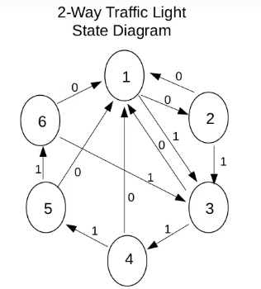

Picture 1-1 traffic light state diagram

The system is an FSM, and one input terminal and one clock terminal need to be set. Let the input end be x, the clock end be clk , and then consider the forced red light state of manual control, the traffic light state table that can be drawn (Table 1-1):

Table 1-1 traffic light status table

|  |  |  |  |
| --- | --- | --- | --- |
| input x | Q1 Q2 Q3 | R1 Y1 G1 | R2 Y2 G2 |
| 0 | 0 0 0 | 1 0 0 | 1 0 0 |
| 0 | 0 0 1 | 0 0 0 | 0 0 0 |
| 1 | 0 1 0 | 1 0 0 | 0 0 1 |
| 1 | 0 1 1 | 1 0 0 | 0 1 0 |
| 1 | 1 0 0 | 0 0 1 | 1 0 0 |
| 1 | 1 0 1 | 0 1 0 | 1 0 0 |
| x | 1 1 0 | 1 0 0 | 1 0 0 |
| x | 1 1 1 | 1 0 0 | 1 0 0 |

According to the design requirements, the timing signal generator is composed of three parts: speed control circuit, state control circuit and LED circuit, and its structural block diagram is shown in Figure 1-2.

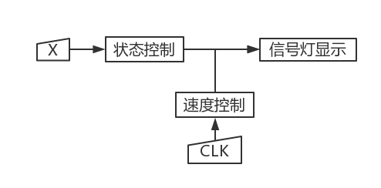

Figure 1-2 Traffic light control circuit system block diagram

**2.1.3 Circuit design**

(1) Speed selection circuit

a. Circuit composition: 1 74163, 4 AND gates, 1 OR gate

b. Working principle: the clock signal is input from the CP terminal of 74153, and the frequency is f, then the frequencies of Q 3, Q 2, Q1, and Q04 output terminals are f/16, f/8, f/4, and f/2 respectively. Each port is ORed with a switch to realize the selection of 4 clock frequencies. In addition, the frequency selection range can also be expanded by using Q3 and Q0 as additional 74163 CPs to lead to more outputs. Periodic signal generating circuit is replaced by logisim clock device here.

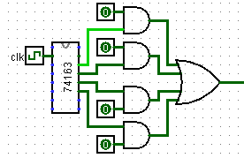

Figure 1-3 speed selection circuit

(2) State control circuit

a. Circuit composition: 3 JK flip-flops, 6 AND gates, 4 OR gates

b. Working principle:

J1=xQ2Q3 K1=/x+Q2+Q3 J2=xQ3+x/Q1 K2=Q3+/x+Q1

J3=/Q1/Q2/x+/Q1/Q2x+Q1/Q2x K3=Q3

of the three flip-flops is jointly controlled by the input x and the six current states of the three flip-flops, and the eight combinations of Q1, Q2, and Q3 correspond to the eight states in the state table.

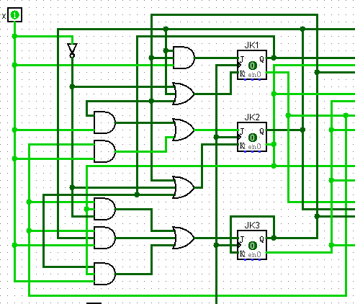

Figure 1-4 state control circuit

(3) Signal light display circuit

a. Circuit composition: 6 AND gates, 4 OR gates, 10 LEDs (signal lights)

b. Working principle:

R1=Q2+/Q1/Q3 Y 1=Q1/Q2Q3 G1=W1=Q1/Q2/Q3 DW1=R1+Y1

R2=Q1+/Q2/Q3 Y 2=/Q1Q2Q3 G2=W2=/Q1Q2/Q3 DW2=R2+Y2

The above output function can be written according to the logical relationship of the signal light itself and the corresponding relationship between the state of the signal light and the state of the trigger in the state table.

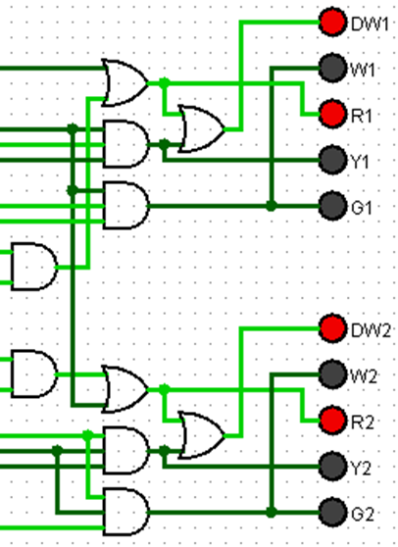

Figure 1-5 signal light display circuit

**2.1.4 l ogisim simulation _**

The signal light control circuit is also state 1 in the state diagram, as shown in Figure 1-6. When x=0, clk=0, all red lights in both directions are on.

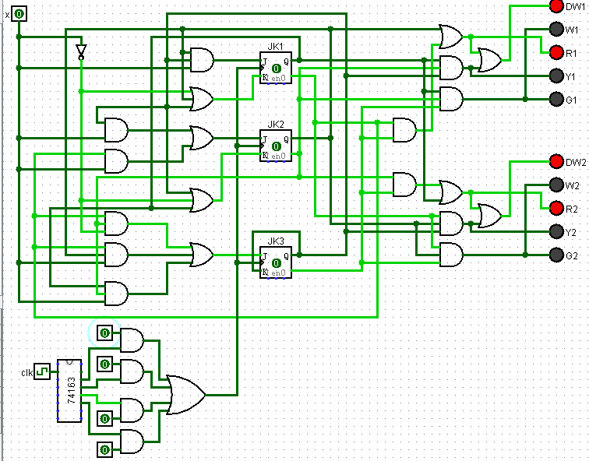

Figure 1-6 state 1

State 2 is shown in Figure 1-7. When x=0, clk=1, all lights are off. The looping of states 1, 2 achieves the traffic light flashing effect when the traffic flow is low.

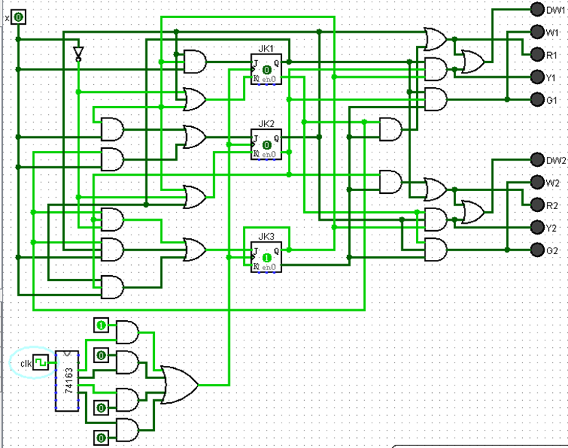

Figure 1-7 State 2

State 3 is shown in Figure 1-8. When x=1, the green light in the second direction is on; the red light in the first direction is on.

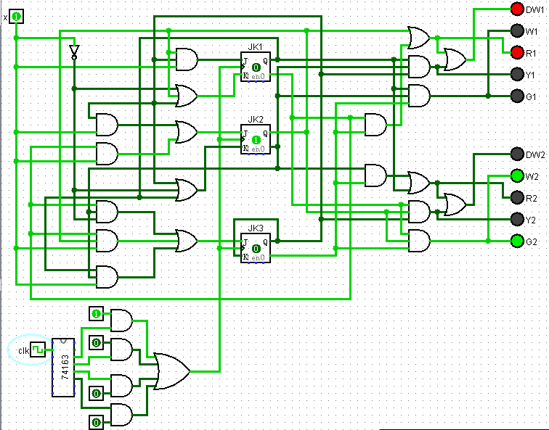

Figure 1-8 state 3

State 4 is shown in Figure 1-9. When x=1, the yellow light on the second carriageway in the direction is on, the red light on the sidewalk is on; the red light in the first direction is on.

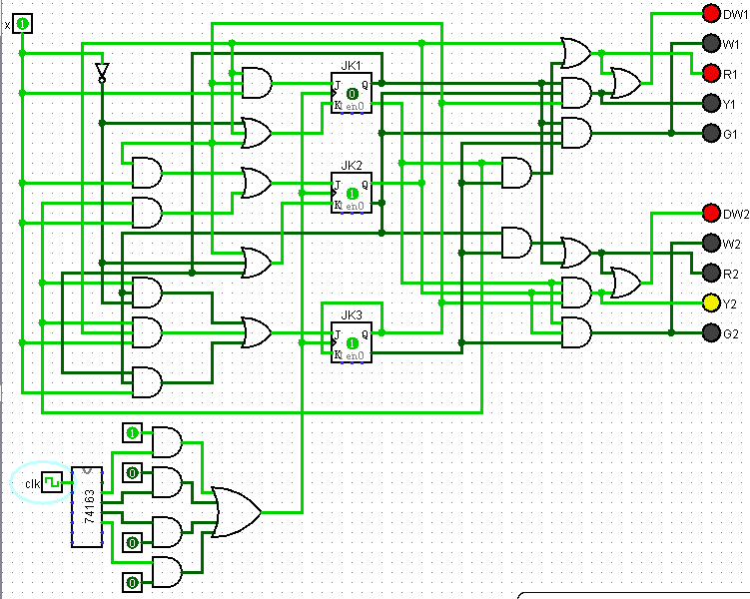

Figure 1-9 state 4

State 5 is shown in Figure 1-10. When x=1, the red light in the second direction is on; the green light in the first direction is on.

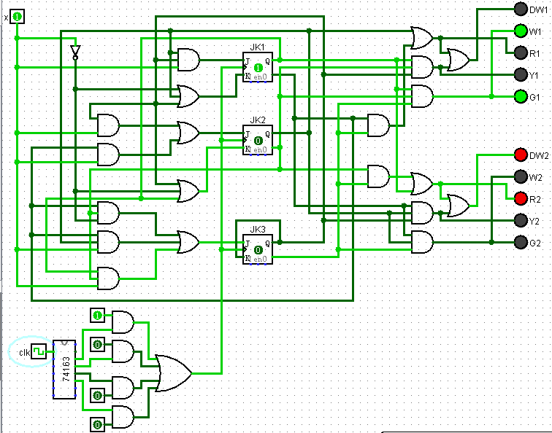

Figure 1-10 state 5

State 6 is shown in Figure 1-11. When x=1, the red light in the first direction is on; the yellow light on the roadway in the second direction is on, and the red light on the sidewalk is on. When the clock is controlled, when x=1, this state will return to state 3; when x=0, it will return to state 1.

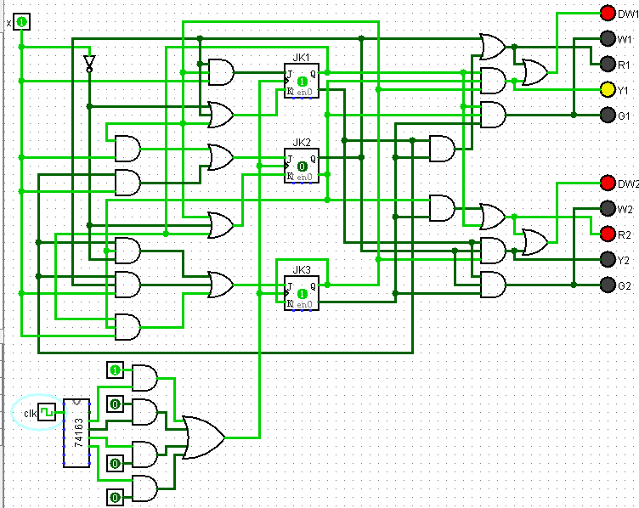

Figure 1-11 state 6

State 7 is shown in Figure 1-12 (it does not change when Q3=1, corresponding to lines 7 and 8 in the state table). At this time, the control of the clock terminal is invalid, Q1 and Q2 are forced to be set to 1, and the red lights are forced to be on in both directions. When the clock terminal is restored, x=0 returns to state 1, and x=1 returns to state 3.

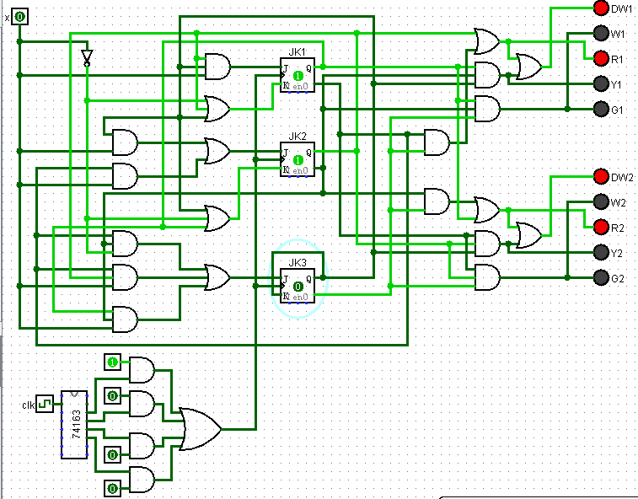

Figure 1-12 State 7

After logisim simulation, it is proved that the traffic light control system has achieved the design goal.

References :

[1] Ouyang Xingming, Yu Junqing, etc. "Digital Logic" (Fourth Edition) Huazhong University of Science and Technology Press, http://www.hustp. com